Steps to configure an Application Load Balancer in AWS
Step 1: Launch the two instances on the AWS management console named Instance A and Instance B. Go to services and select the load balancer. To create AWS free tier account refer to Amazon Web Services (AWS) – Free Tier Account Set up.
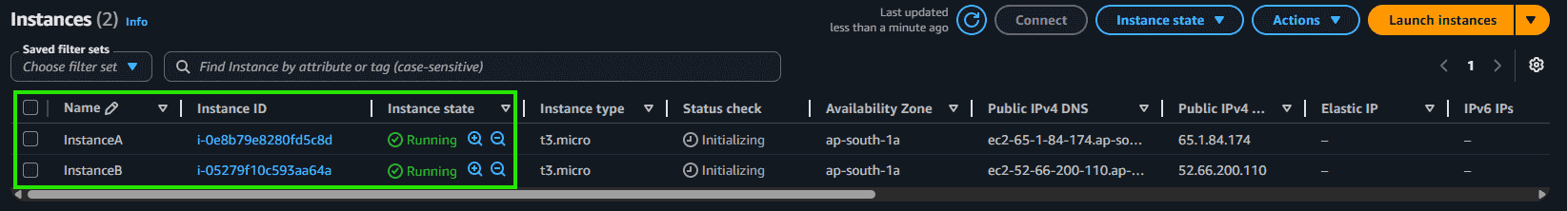
Step 2: Scroll down on the left side panel, go to Load Balancers, and click on Create Load Balancer.
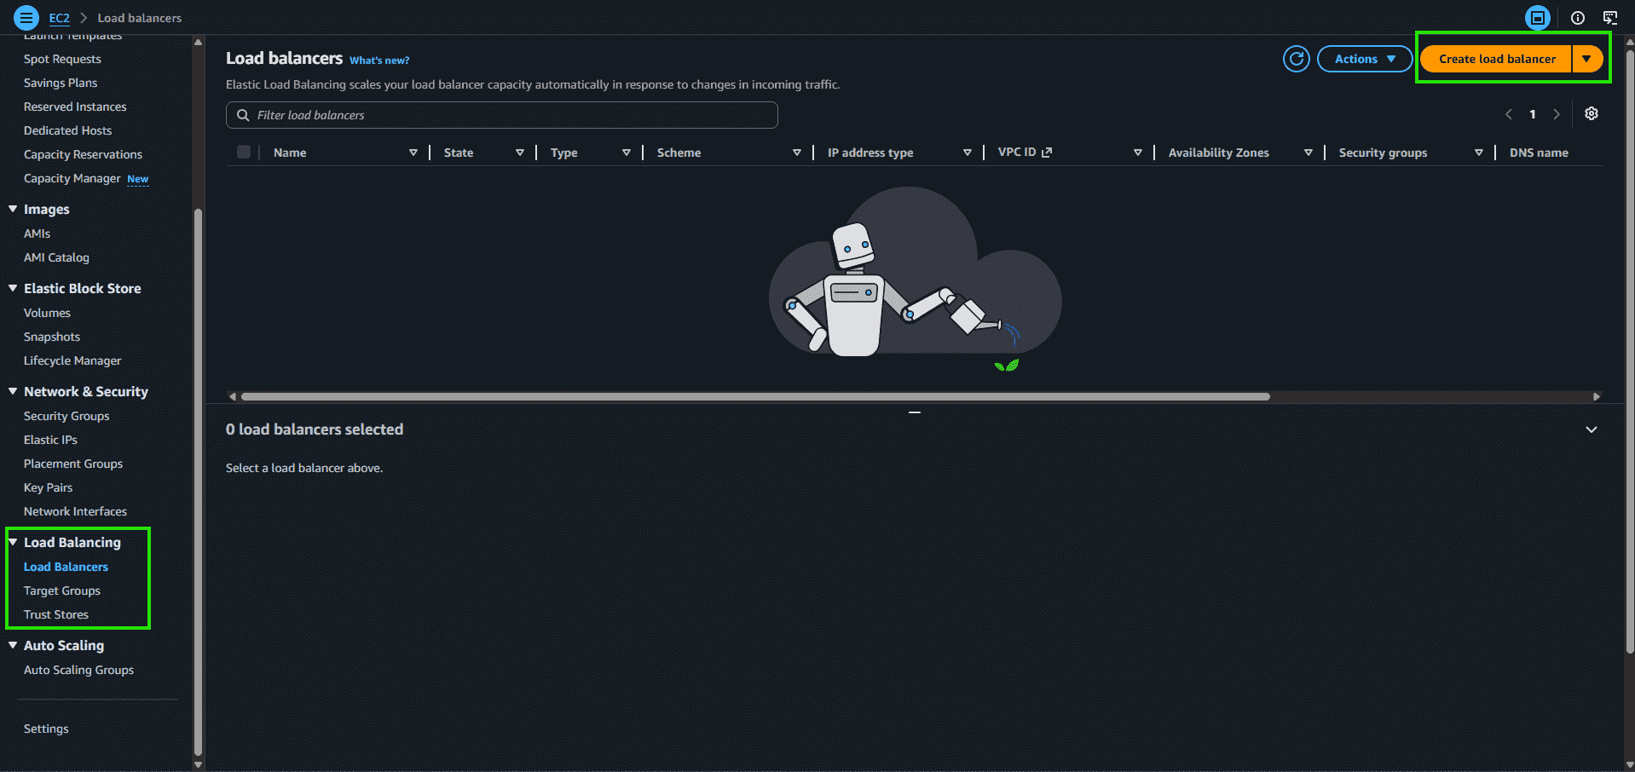
Step 3: Select Application Load Balancer and click on Create.
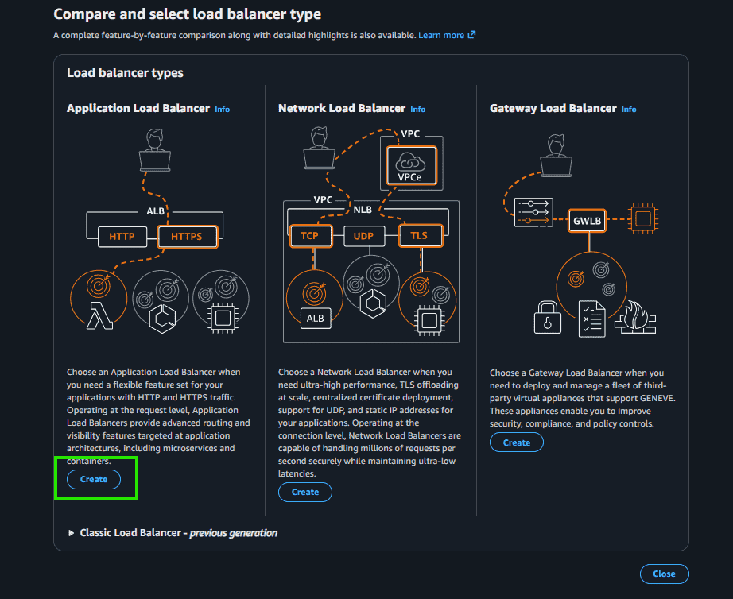
Step 4: Here you are required to configure the load balancer. Write the name of the load balancer. Choose the scheme as internet facing.
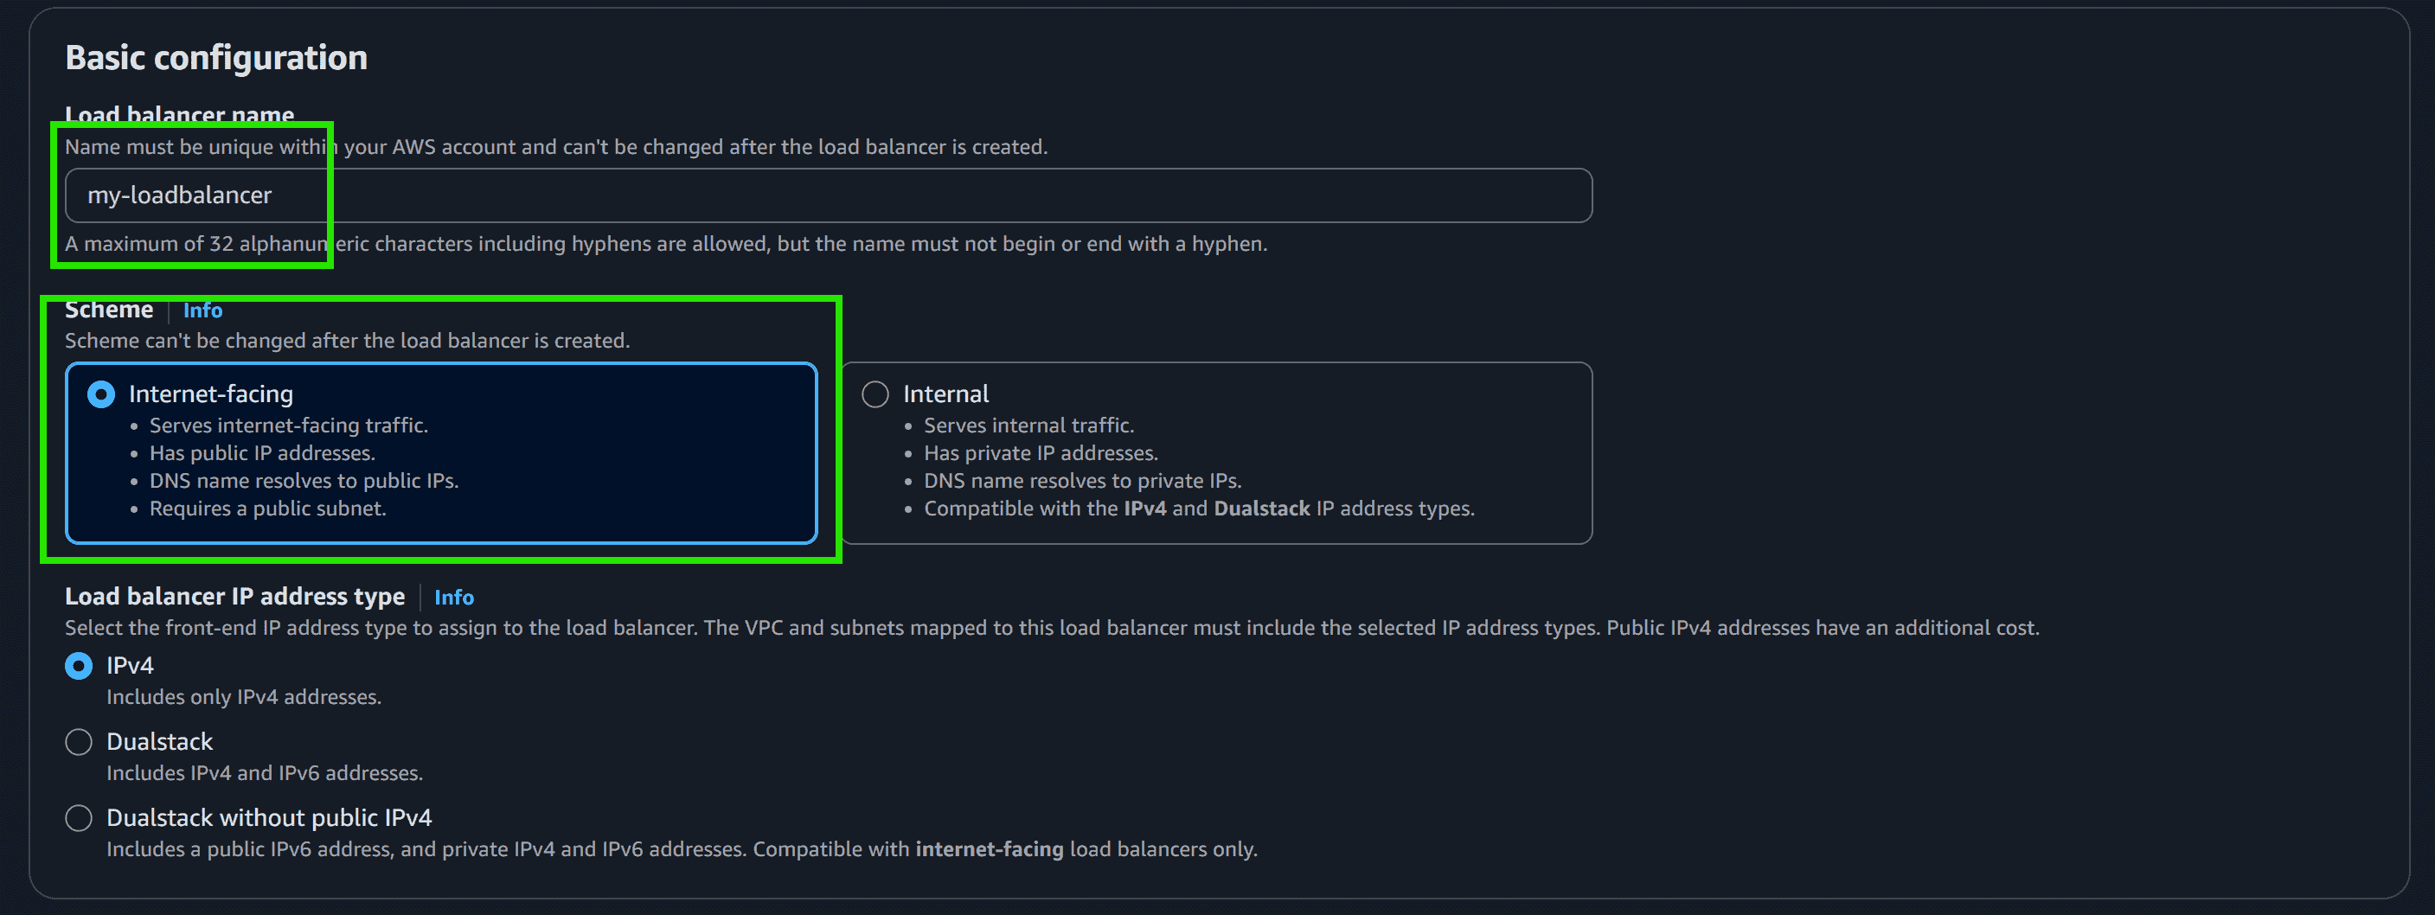
Step 5: Add at least 2 availability zones. Select us-east-1a and us-east-1b
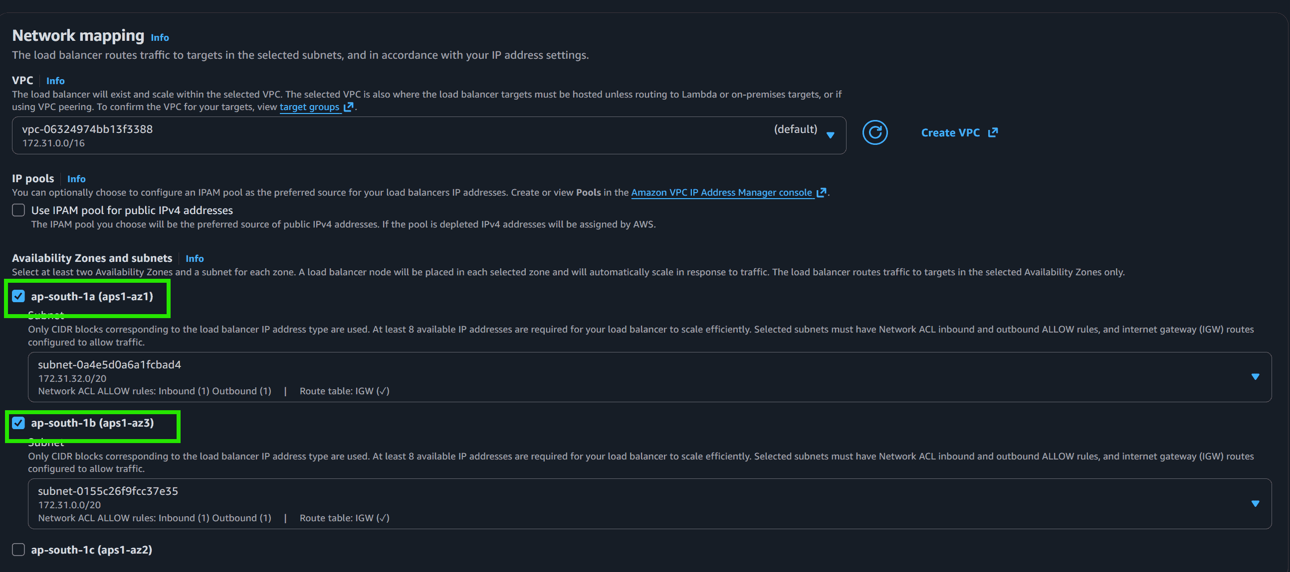
Step 6: Select the default security group.
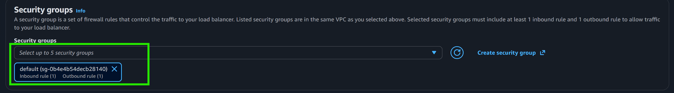
Step 7: In the Listener and Routing section, click on Create New Target Group.
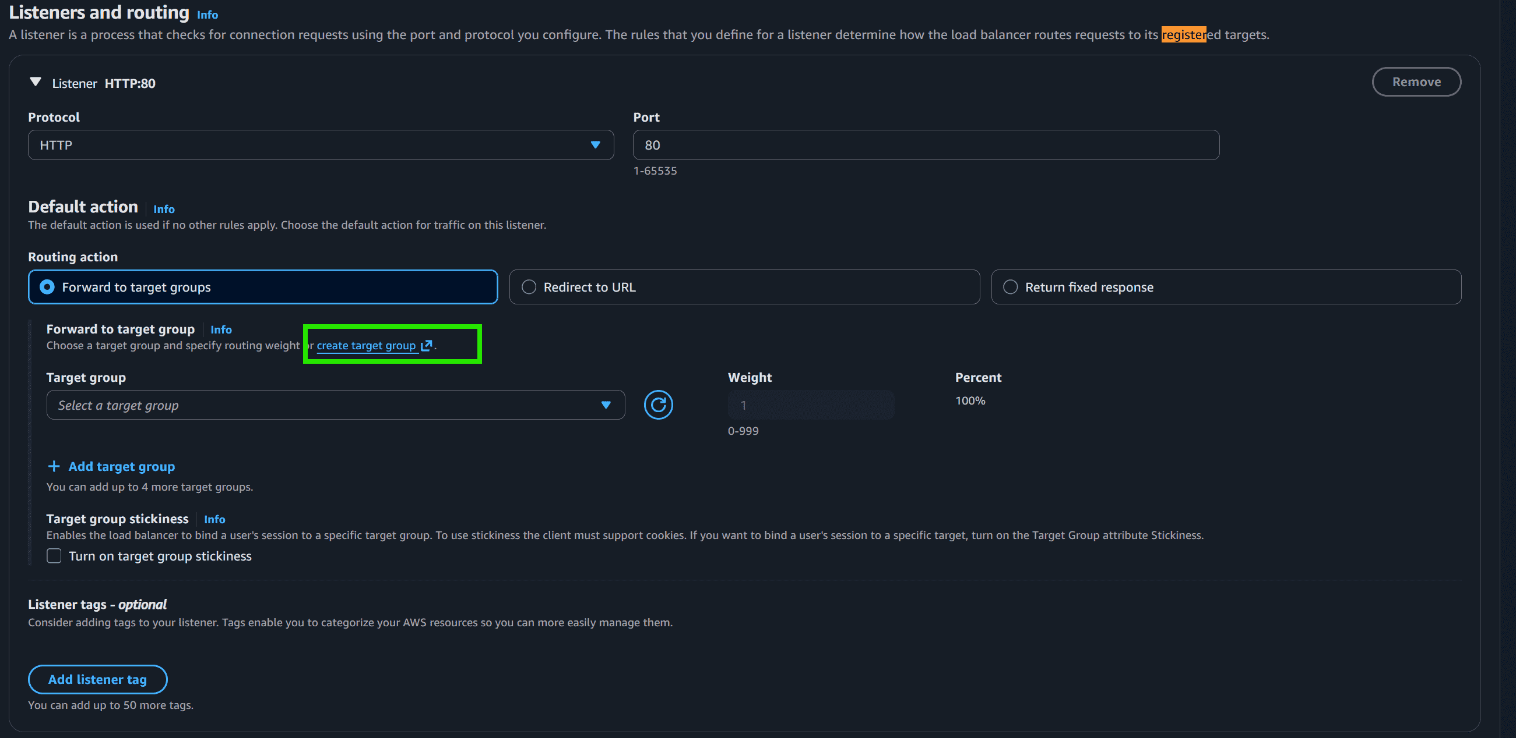
Step 8: Choose the Target Group Name, select the Protocol, and enter the Port Number.
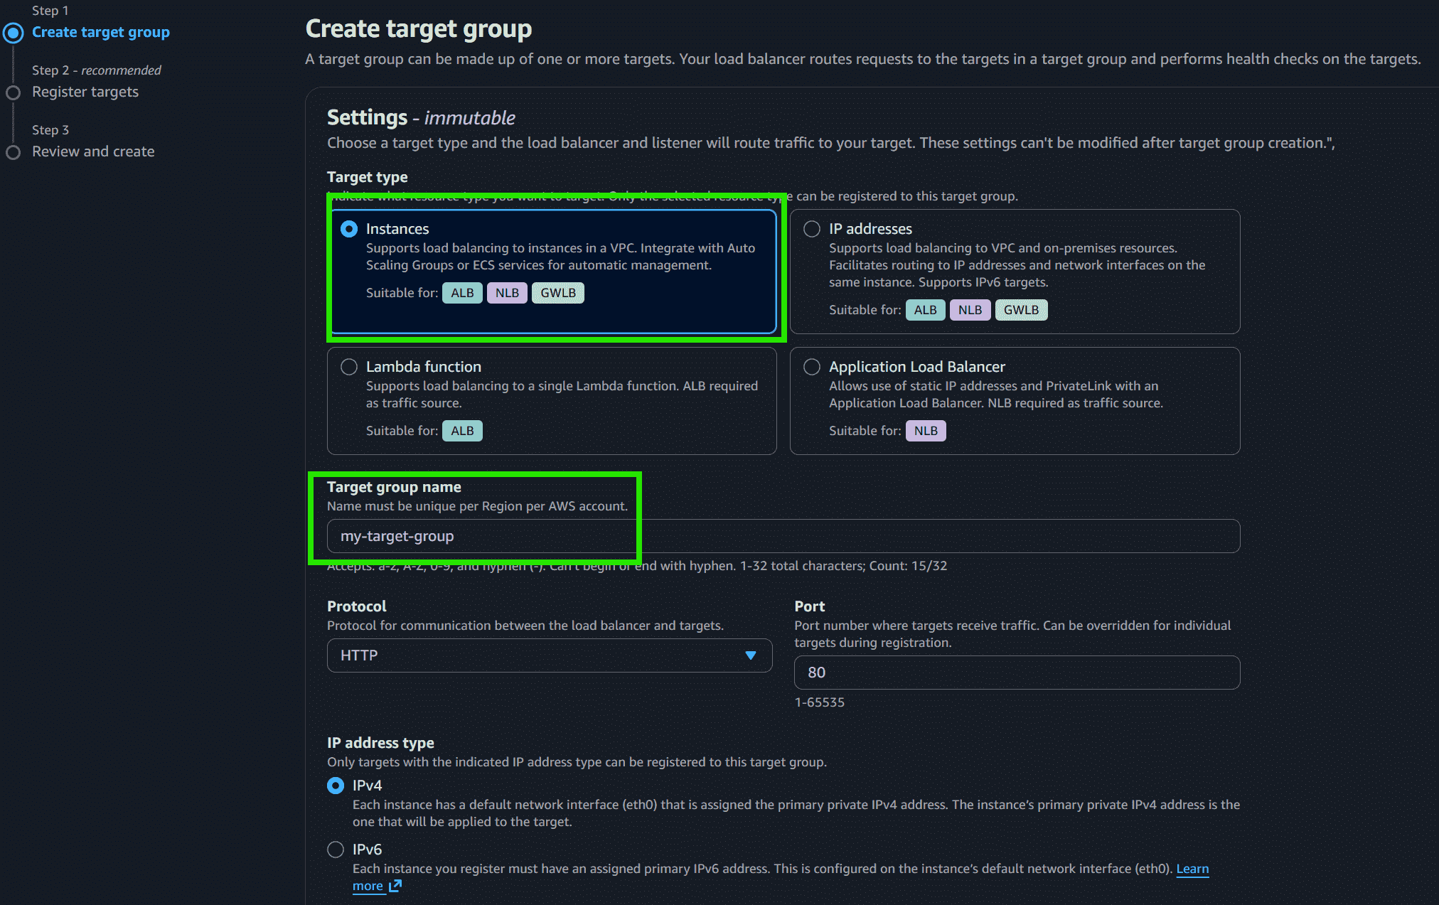
Step 9: Choose instance A and instance B and Click on Next: Review.
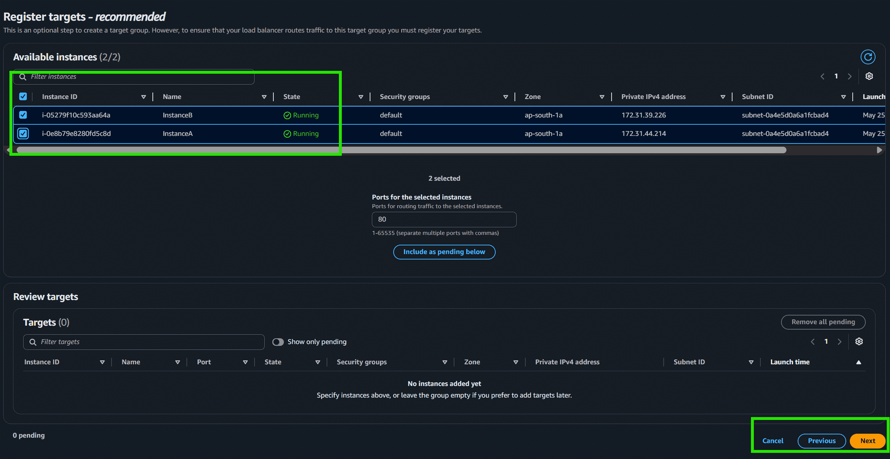
Step 10: Review all the configurations and click on Create Target Group. After that, return to the Load Balancer Creation page and select my-target-group in the routing section.
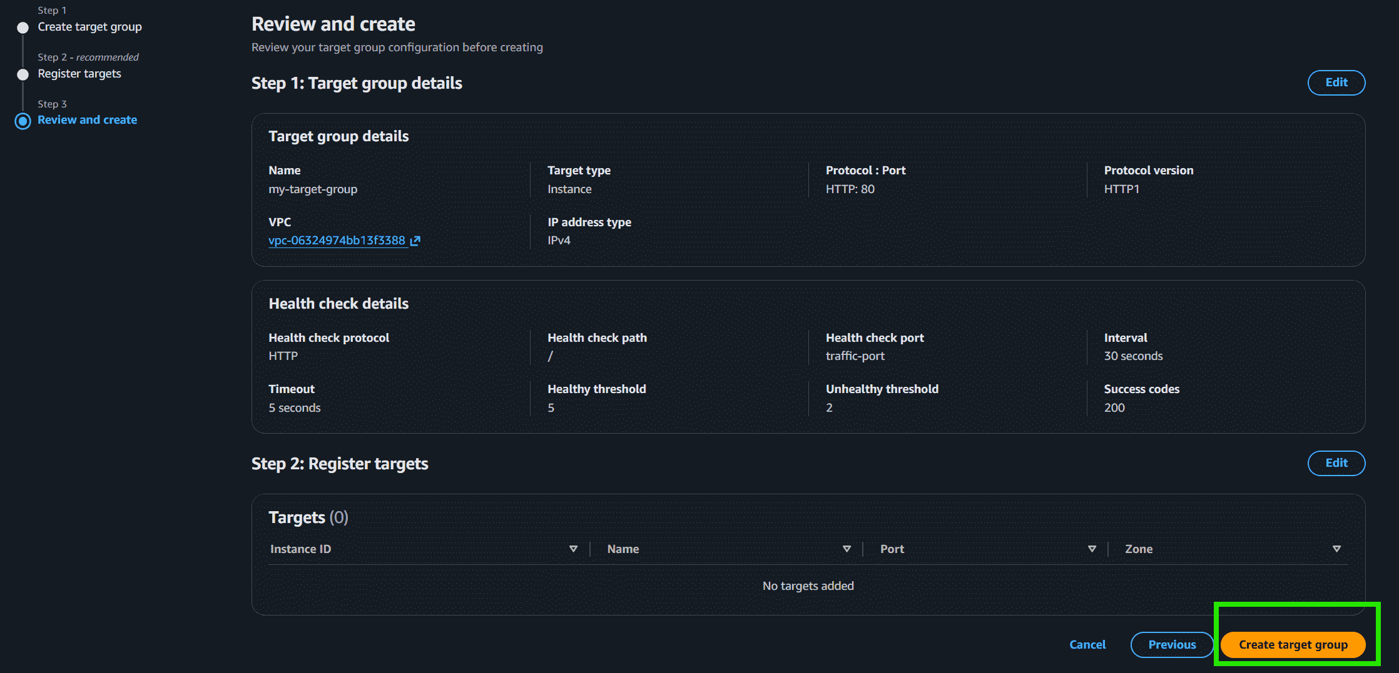
Step 11: Scroll down and click on Create Load Balancer.
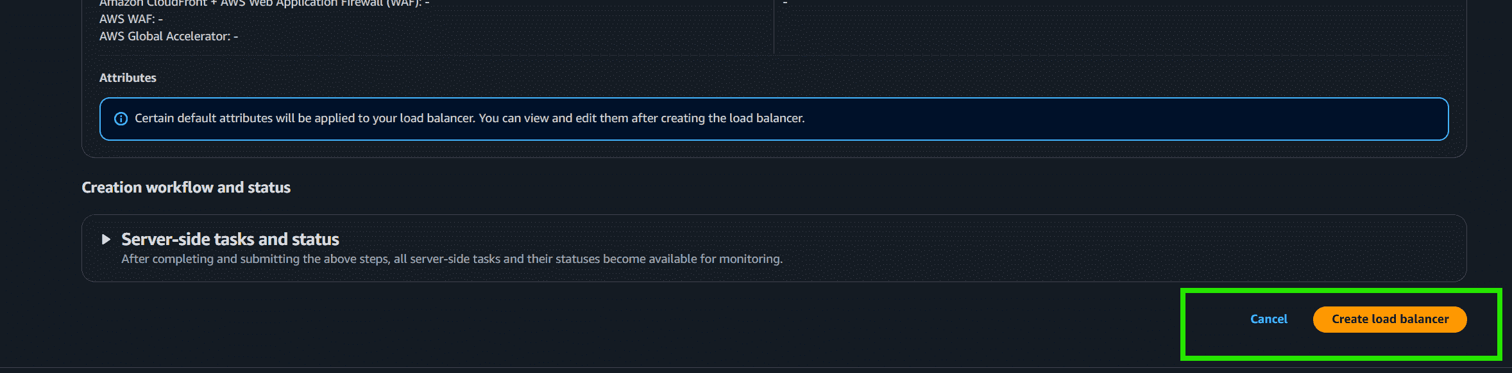
Step 12: Congratulations!! You have successfully created a load balancer.
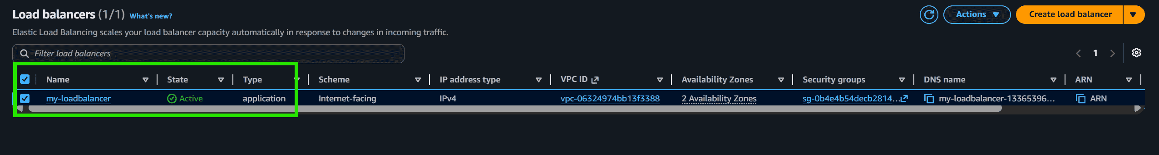
Step 13: This highlighted part is the DNS name which when copied in the URL will host the application and will distribute the incoming traffic efficiently between the two instances.
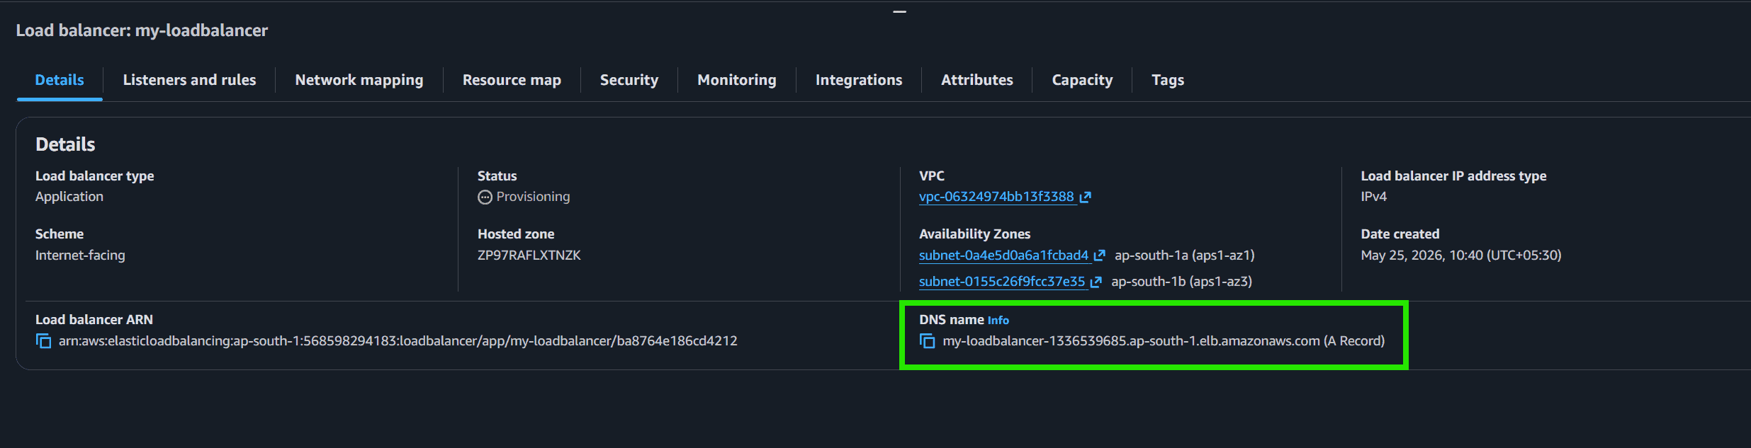
Step 14: This is the listener port 80 which listens to all the incoming requests
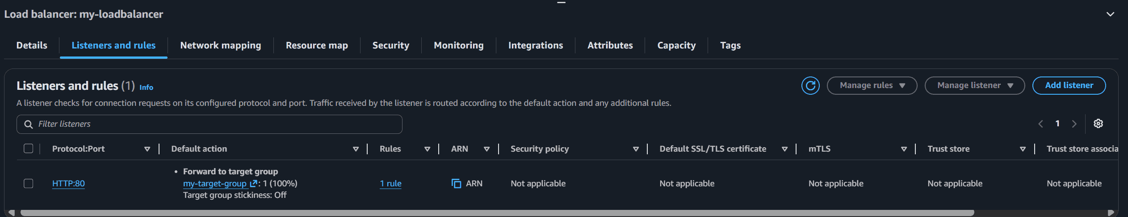
Step 15: This is the target group that we have created
Step 16: Now we need to delete the Load balancer. Go to Actions -> Click on Delete.
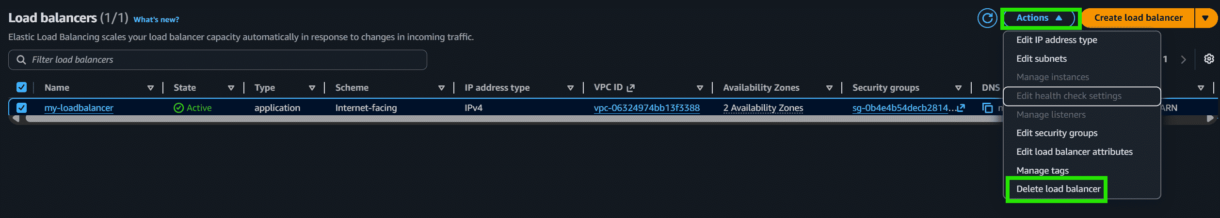
Step 17: Also don't forget to terminate the instances.
